Sporty Shoes Project Specification Document

Course : Implement Frameworks the DevOps way

Programmer Details: Diksha Pratap Kadam

**Screenshots of all Scenarios in the Application for Admin:** 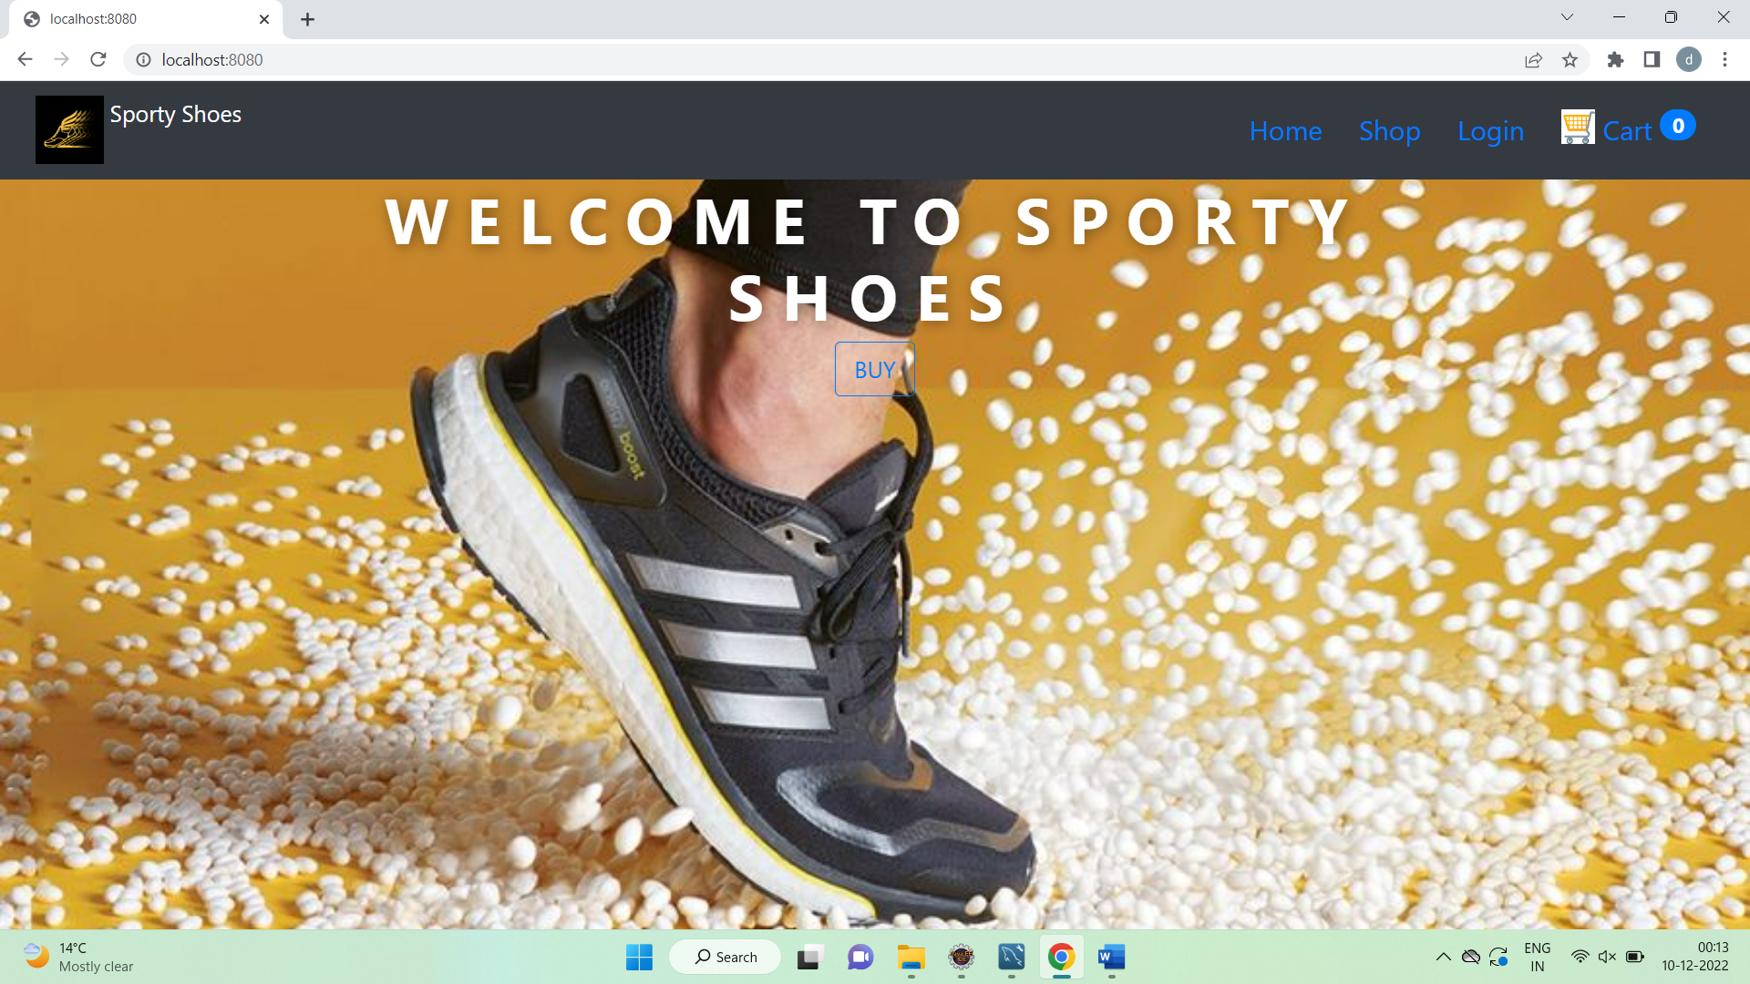

**Login using Admin Credentials : User has Admin Role in DB**

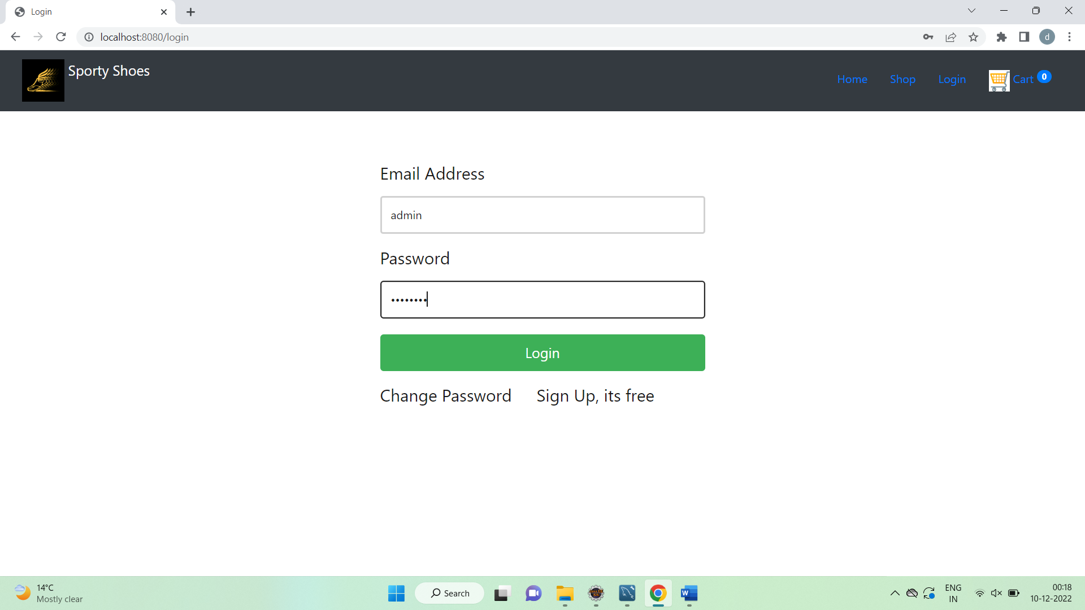

**On Successful Login Admin Dashboard is shown with Admin user name in Nav .**

**Admin Page Shows all the available Management Links available to Admin user**

**to manage the website data.**

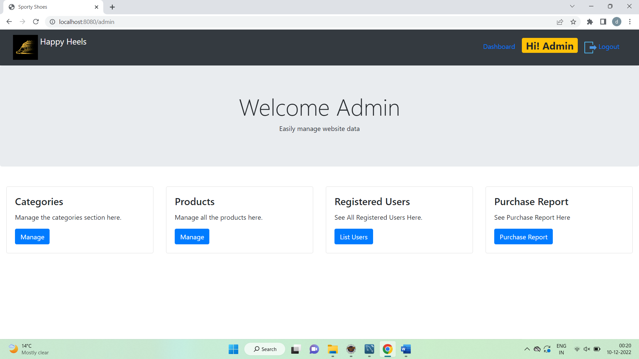

**Category Management : List of available categories with option to edit or delete existing category**

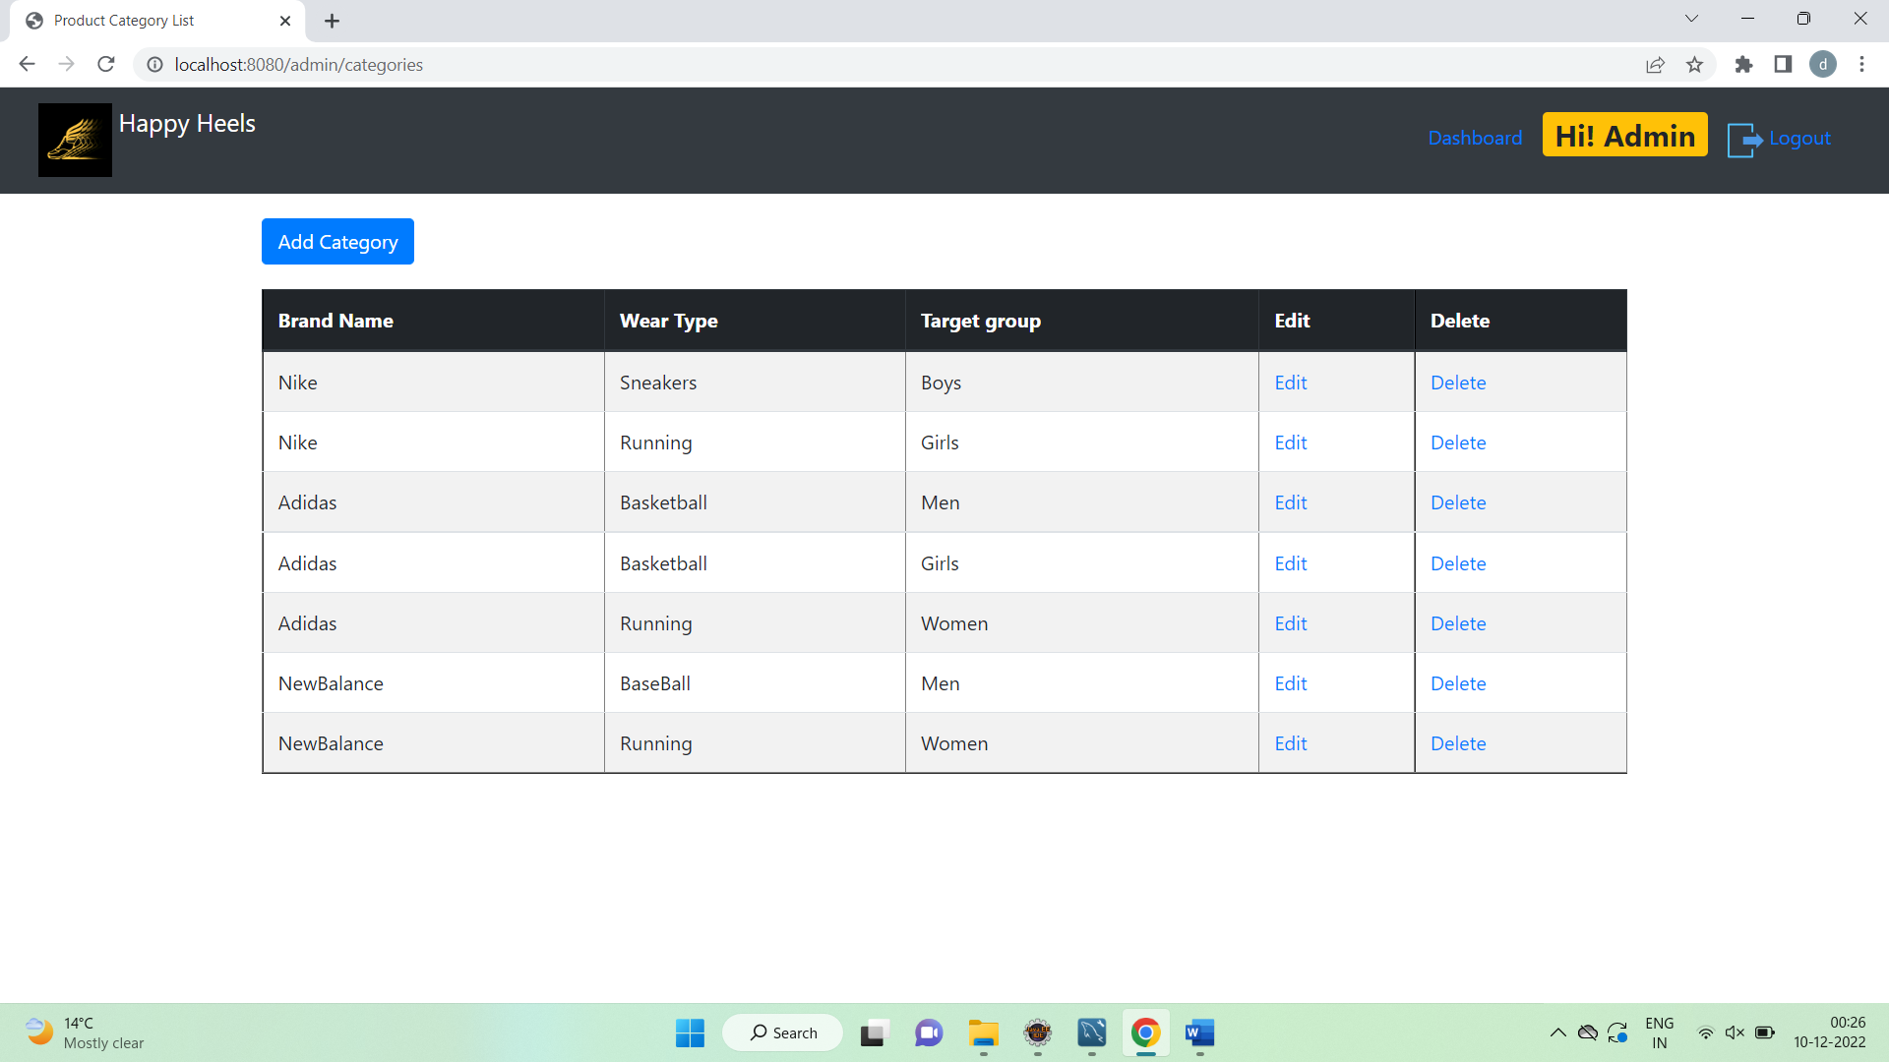

**Add new Category**

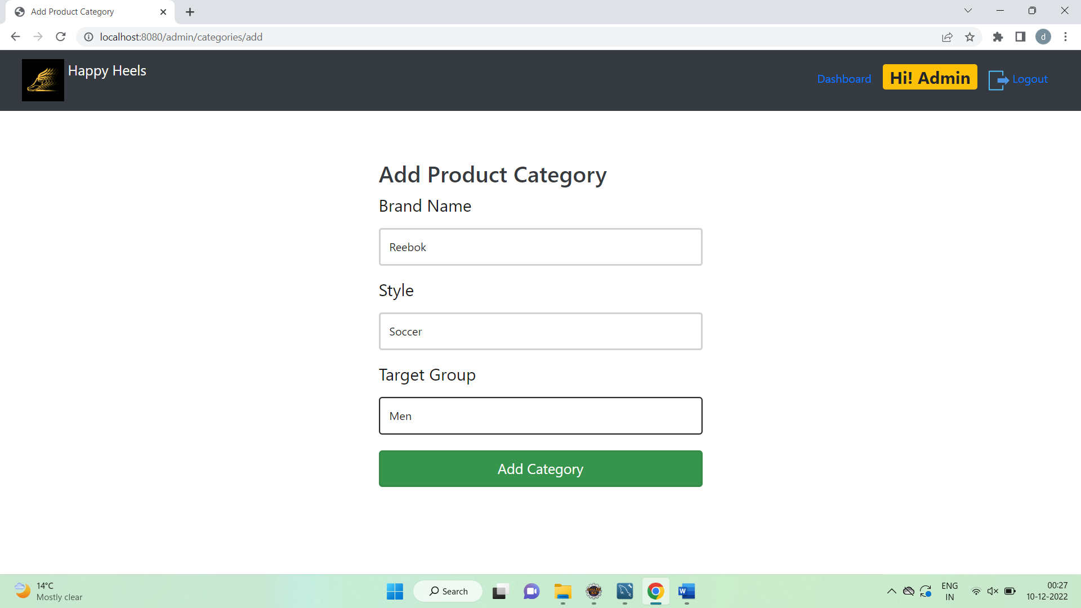

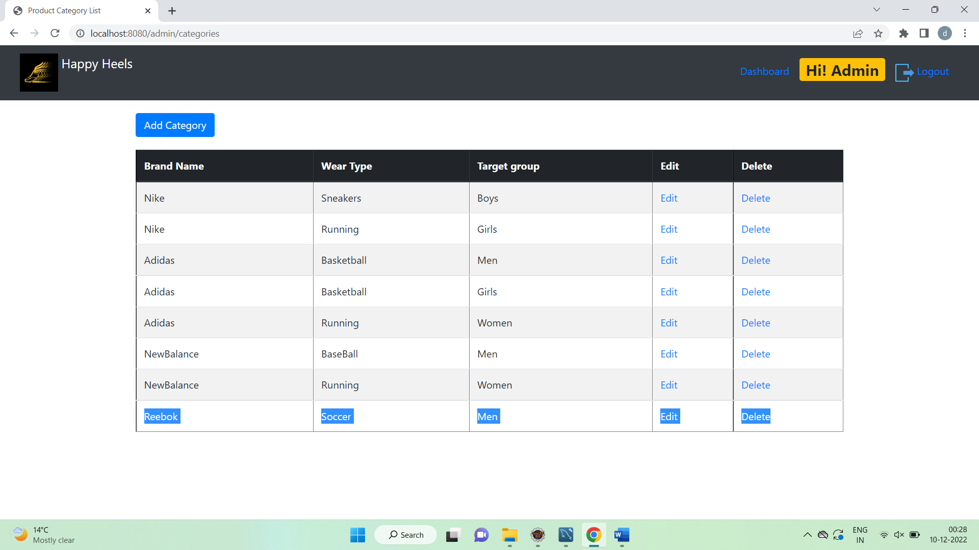

**Manage Product – list of available products with preview image.**

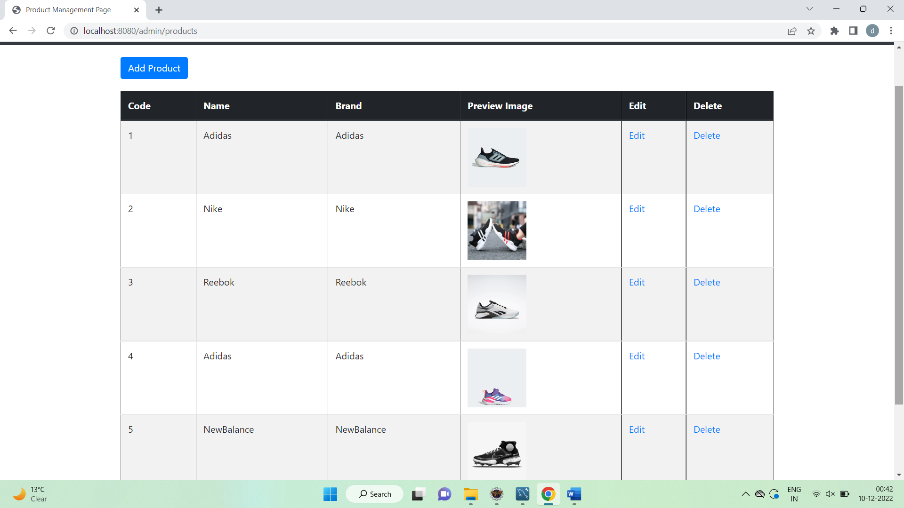

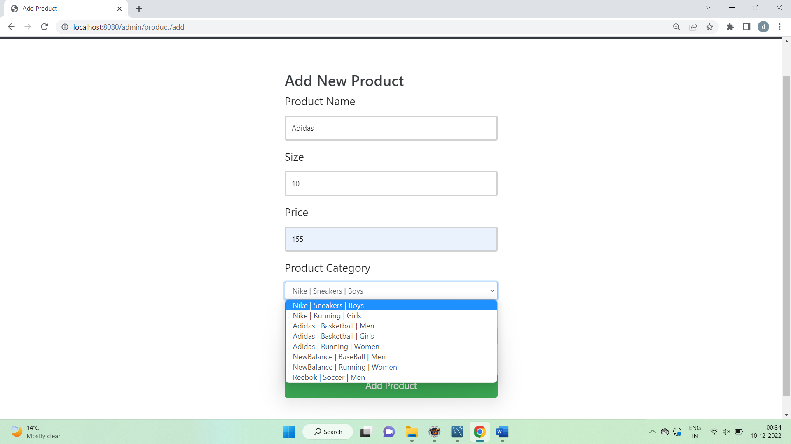

**On clicking browse**

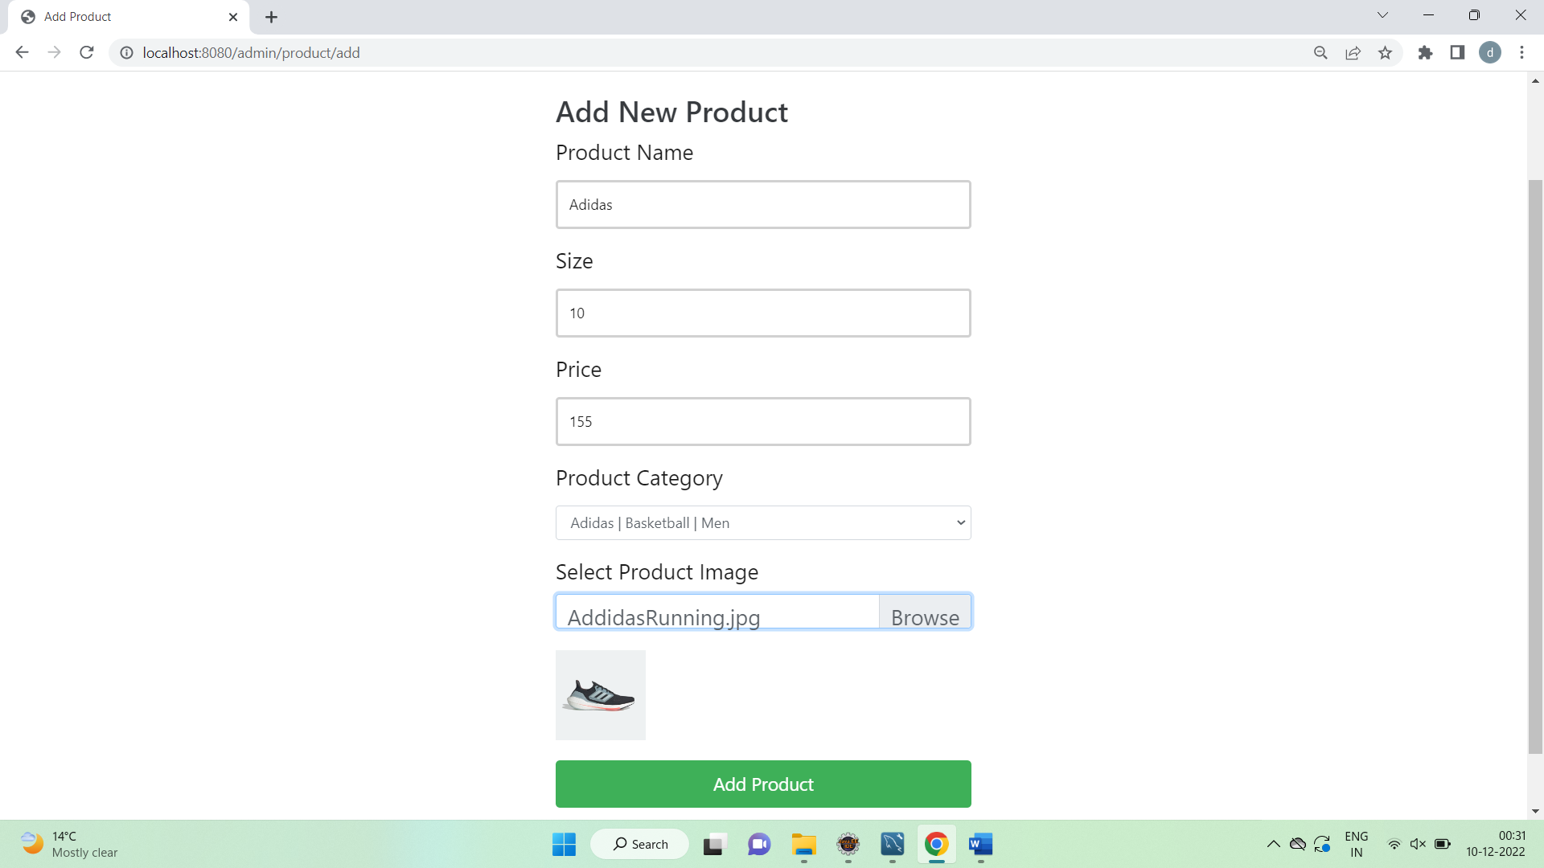

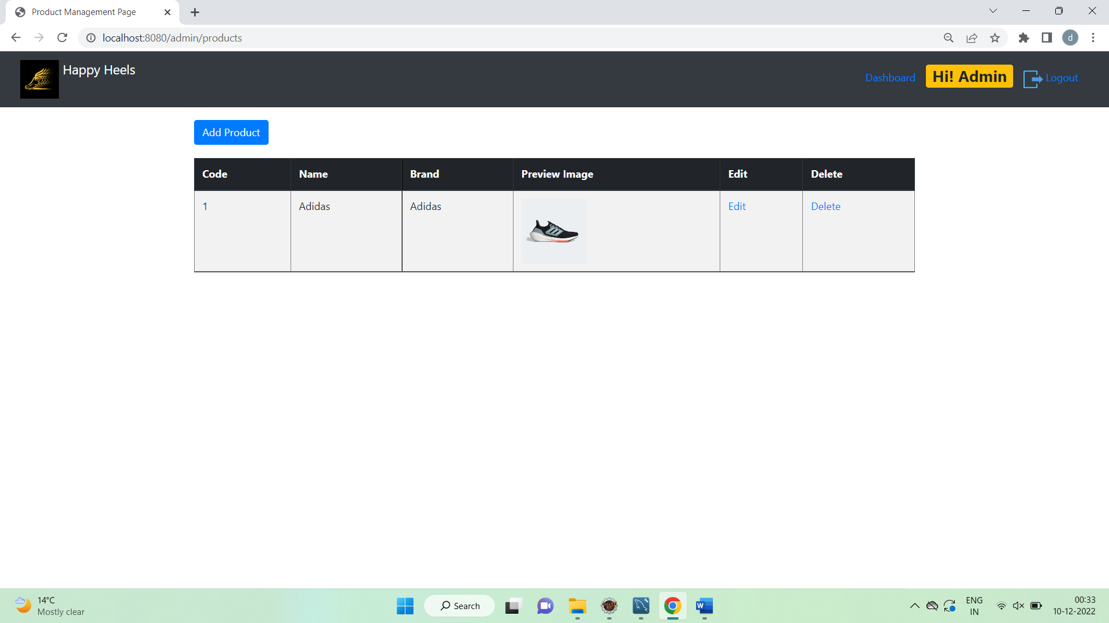

**Database updated .Product List also includes added Shoe**

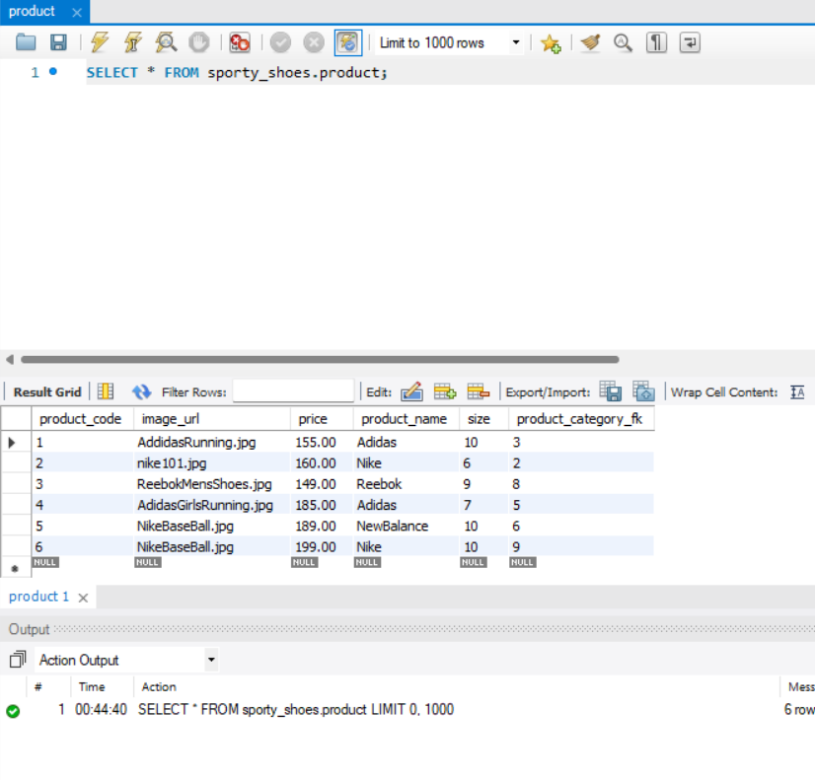

**Registered Customer List**

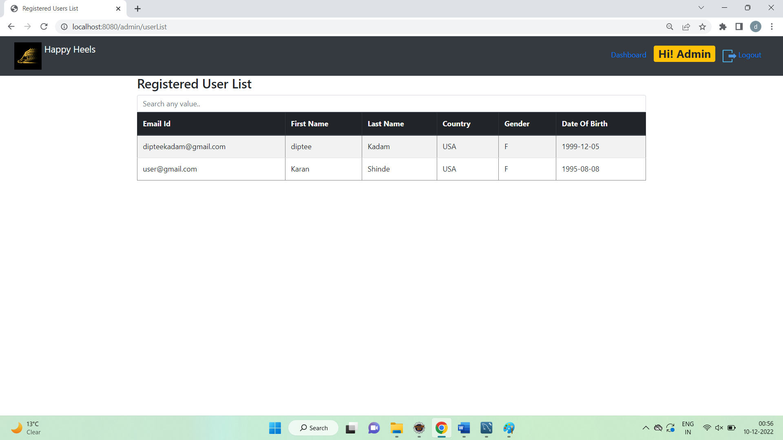

**Admin can filter by any field**

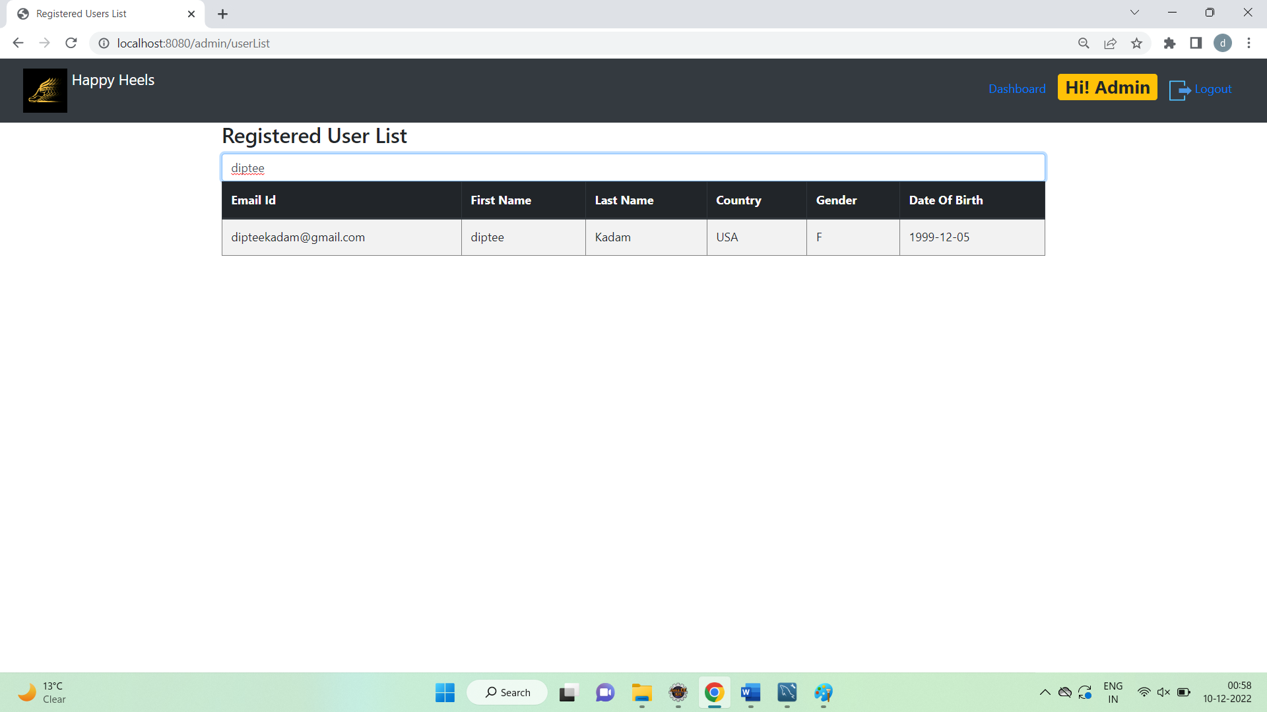

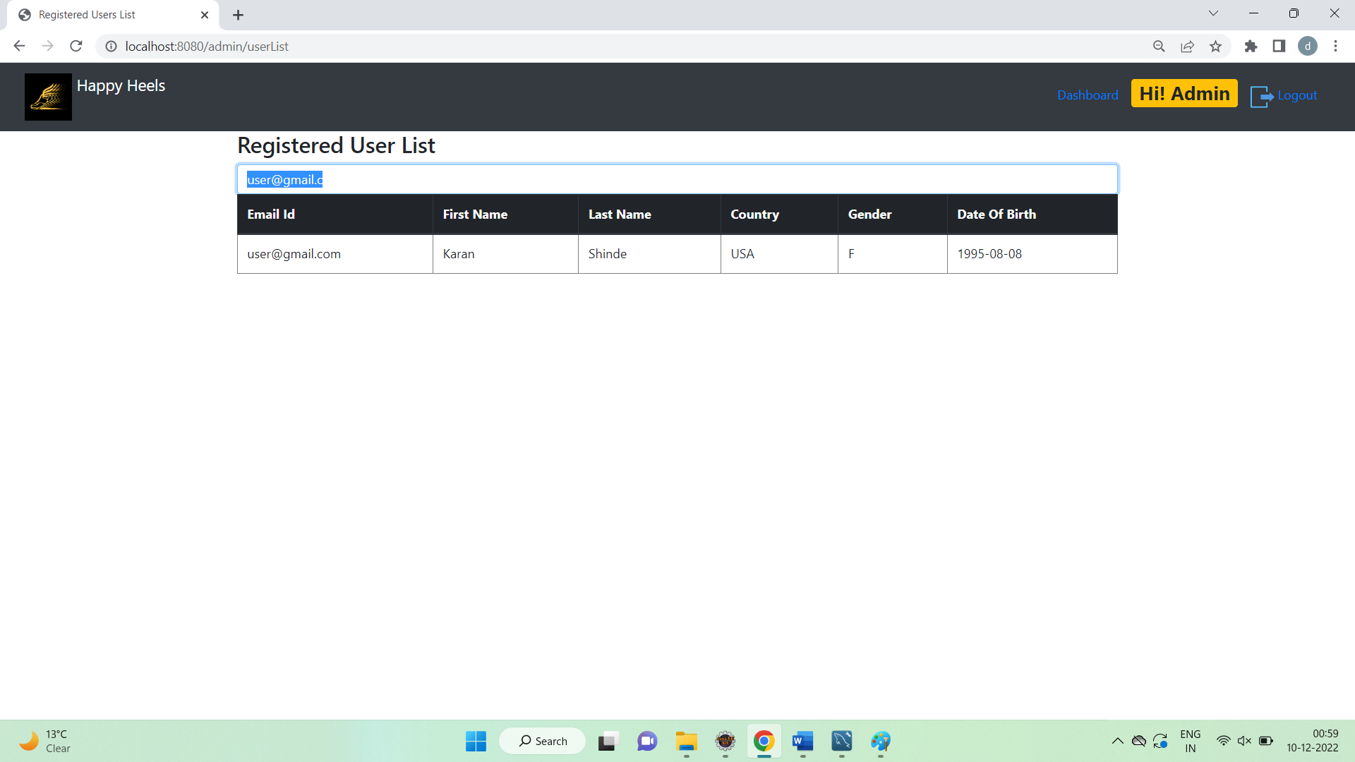

**Purchase Report of all orders with User and Product details**

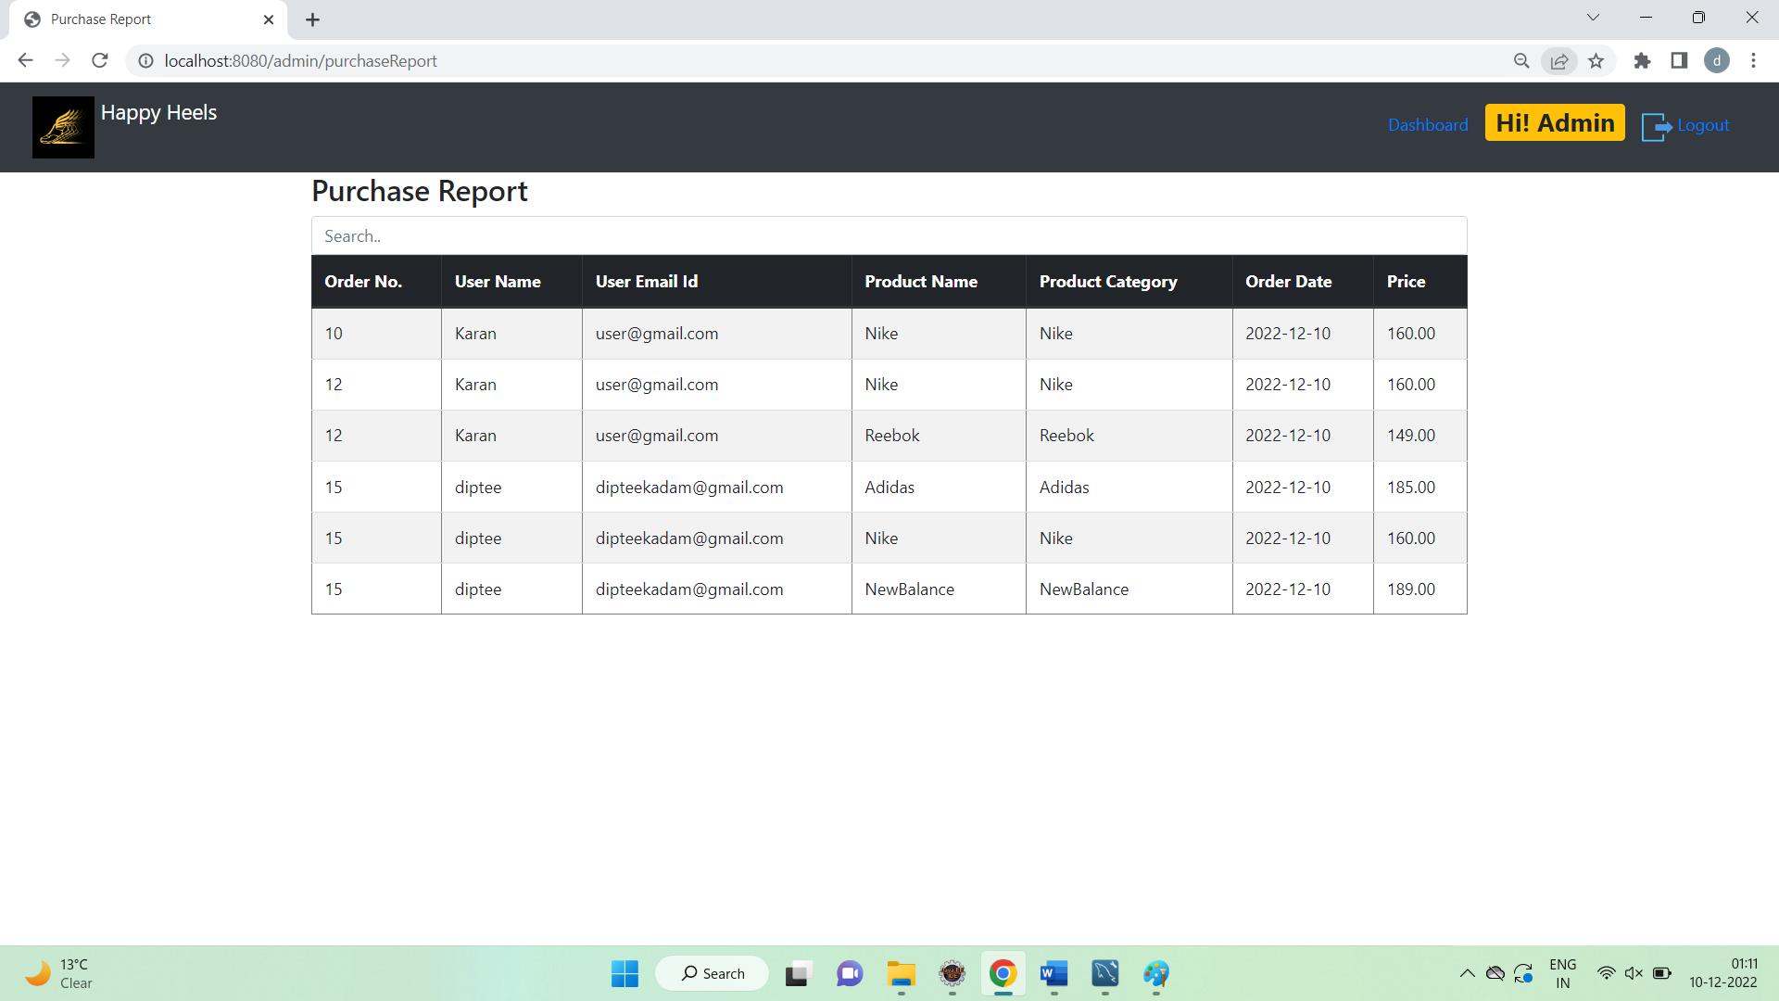

**Filter data by category**

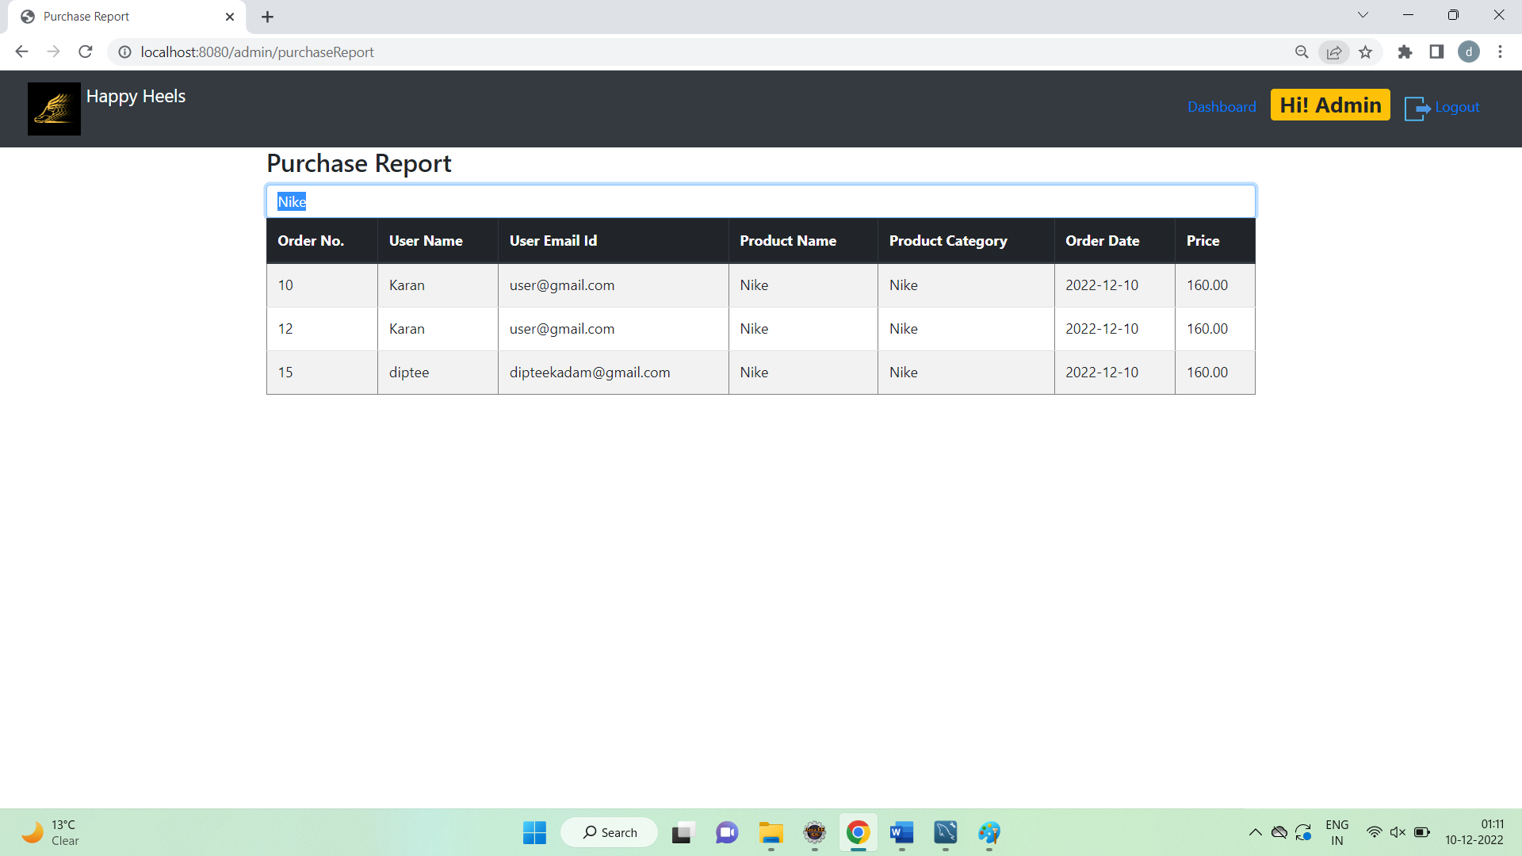

**Filter data by date**

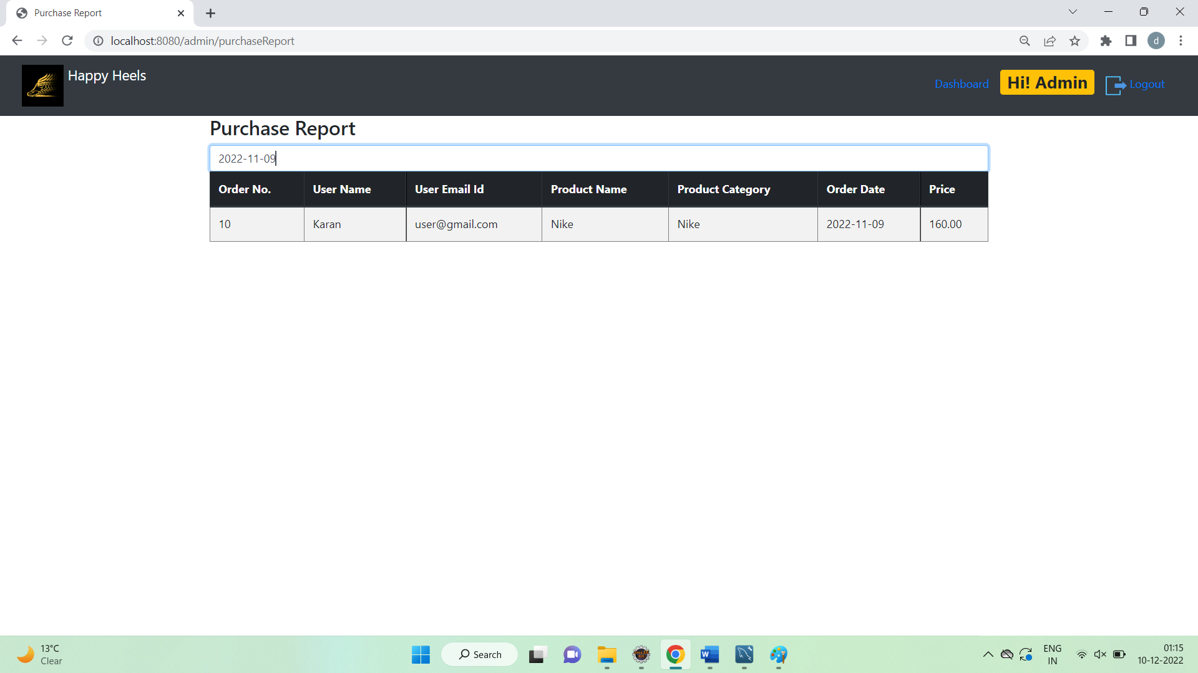

**Filter by Order No**

